Synthesis of ATP, the energy currency in metabolism
Note that these are simplified summaries to support lecture material

Either Substrate-level phosphorylation (SLP)
Or Electron transport phosphorylation (ETC): this is Oxidative phosphorylation or Photophosphorylation

Substrate-level phosphorylation (SLP) Very few reactions are directly involved
Eg in glycolysis as in the fermentation of glucose to pyruvate:

H₂O Pi

Phophoglyceraldehyde Bisphosphoglycerate Phosphoglycerate

NAD NADH₂ ADP ATP
In these reactions the energy for making ATP is provided by the oxidation of phosphoglyceraldehyde to the acid. During the 1st reaction, catalysed by a dehydrogenase, the substrate becomes phosphorylated. In the second reaction, catalysed by phosphoglycerate kinase, the phosphate is transferred to ADP to make phosphoglycerate. In glycolysis this reaction is followed by a second SLP reaction:

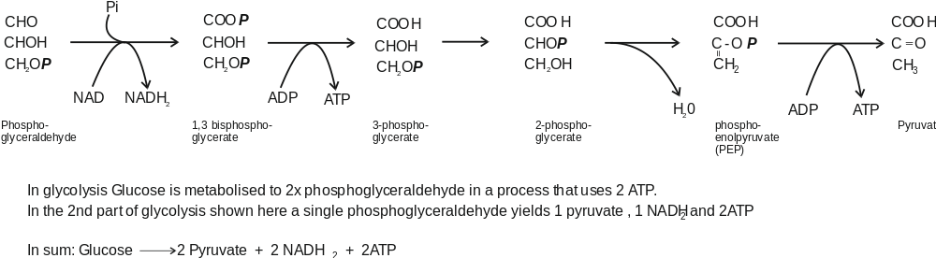

Other Substrate level phosphorylations involving acyl phosphates
Acetyl-CoenzymeA and butyryl-CoenzymeA are energy rich compounds. After they are produced in fermentation pathways they can be converted to acetyl phosphate and butyryl phosphates (also energy-rich compounds) which can provide phosphate to convert ADP to ATP.

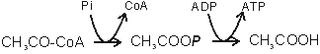

Oxidative phosphorylation
This process is similar in mitochondria and in many bacteria. Phosphorylation of ADP to ATP is catalysed by a membrane-bound ATP synthase (also called ATPase). The energy for this is provided by the oxidation of NADH₂ by oxygen, catalysed by an electron transport chain. This sequence of redox reactions leads to movement of protons from inside to the outside, producing protonmotive force (electrochemical gradient of protons) that is used to drive protons back in by way of the ATP synthase, providing the energy for phosphorylation. The oxidation of one molecule of NADH is coupled to (approx.) phosphorylation of 3 ADP:
NADH₂ + 0.5 O₂ NAD + H₂O Coupled to 3ADP + 3Pi 3ATP

Components of the electron transport chain (ETC)
These constitute a series of redox components, arranged in (or attached to) the inner mitochondrial membrane (or bacterial periplasmic membrane). Their sequence is determined by their Redox potentials. The electrons flow from the more negative potential to the highest potential (oxygen). Three important features of the components are:-
Protein or non-protein; redox potential; whether a ‘2H’ carrier (2 protons plus 2 electrons, single electron carrier).

Flavoproteins
Membrane proteins. 2H carriers. Eº = about -200mV.
The part of the flavoprotein that carries the electrons (the prosthetic group) is a riboflavin derivative; the 3-ring structure can carry 2H atoms. NADH dehydrogenase has Flavin mononucleotide FMN (reduced form is FMNH₂); Succinate dehydrogenase has Flavin adenine dinucleotide FAD (reduced form is FADH₂).
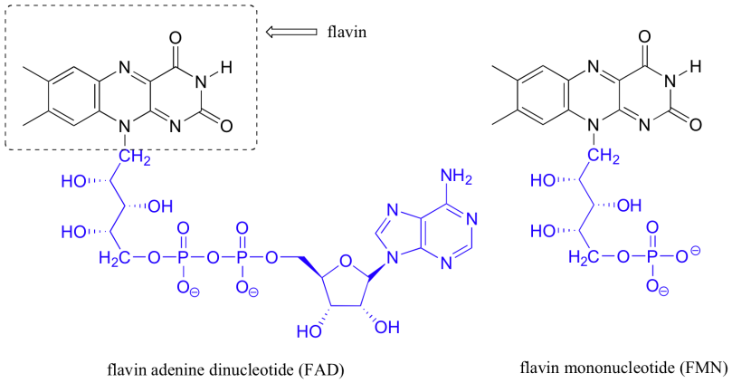

Iron-sulphur proteins
Membrane proteins. Single electron carriers: Fe³⁺ Fe²⁺ Eº depends on the complex that it is in.
The prosthetic group containing the iron is called an Iron/Sulphur Centre (Fe/S centre). In NADH dehydrogenase and in cytochrome bc1 (Complex 3).

These vary in how many iron and sulphur atoms are present. Even if the Fe/S centre has more than one iron atom it will be involved in transfer of a single electron.  The cysteines that bond to the iron atoms are part of the amino acid sequence of the protein. | 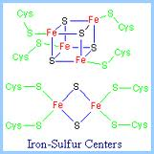

Ubiquinone (Coenzyme Q, UQ)
This carries 2H. Reduction and oxidation occurs in 2 steps, with a semiquinone free radical intermediate (half reduced). Eo = 0 mV. This is the only component that is not a protein. It has a simple quinone/quinol structure with a hydrophobic ‘tail’ that keeps makes it soluble in the membrane. It carries 2H between membrane proteins.

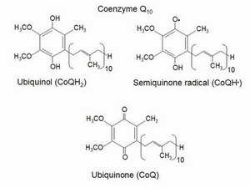
Cytochromes
Proteins that have a haem prosthetic group, with an iron atom that carries a single electron: Fe³⁺ Fe²⁺
The haem is a tetrapyrrole. The iron atom has 6 ligands. 4 are the N atoms of the pyrroles. The 5th ligand is a N atom of a histidine. The 6th ligand defines the cytochrome.
Cytochrome b has haem b. Eº = -60 / -90mV The 6th ligand is N of histidine in haem a and O2
Cytochrome aa₃ The membrane cytochrome oxidase has two haem a, Eº = +440 mV The 6th ligand is N of histidine (haem a) or O₂ in haem a₃.
Cytochrome c has covalently bound haem c. Eº = +260 mV. The 6th ligand is S atom of methionine.
Haem prosthetic groups in cytochromes
These are tetrapyrroles in which the 4 N atoms are coordinated to an iron atom that can be in the reduce (Fe²⁺) or oxidised form (Fe³⁺). The iron atoms have six ligands. The 5th is always to a histidine N in the cytochrome and the 6th ligand varies. This picture shows the tetrapyrroles face on.
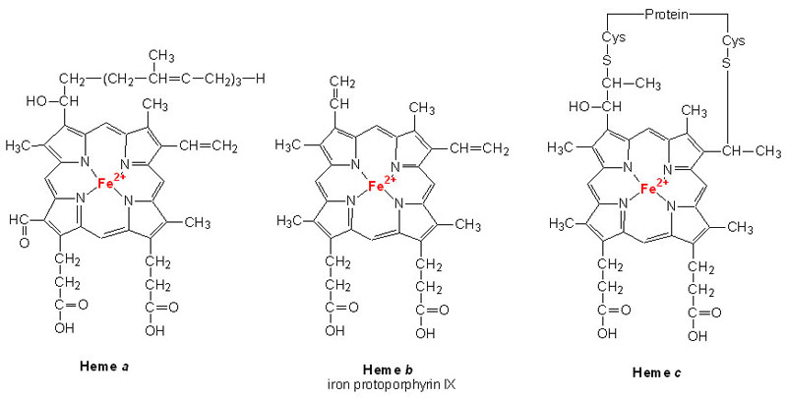
Haem b in space filling mode  Iron is the grey central sphere  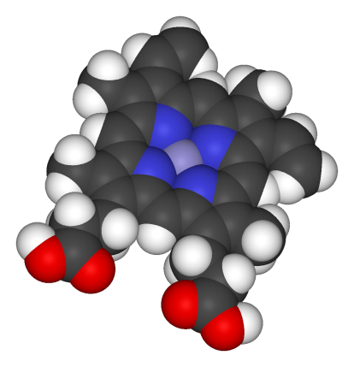 | Cytochrome c showing the histidine and methionine 5th and 6th ligands  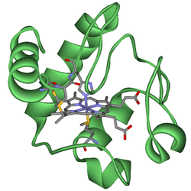 | Cytochrome a3 in cytochrome oxidase. The 5th ligand is Histidine. The 6th (not shown is oxygen or water  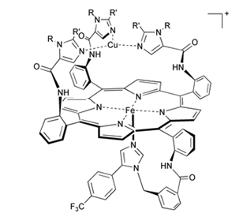
The electron transport chain
Electrons flow from a high negative redox potential to high positive potential. NADH₂ + 0.5 O₂ H₂O
The membrane proteins were named according to their sequence of isolation (Complexes I – IV)

NADH₂ complex I Complex III Complex IV
NADH₂ → NADH dehydrogenase → UQ → Cyt bc1 Cyt c → Cyt oxidase → O₂
-320 mV 0 mV +260 mV +880 mV

NADH dehydrogenase (complex I). This is a huge complex with many proteins. Prosthetic groups are FMN and Fe/S proteins. Catalyses oxidation of NADH2 to NAD coupled to reduction of UQ to UQH2

Cytochrome bc1 (Complex III). Large protein complex that 2 haemb, 1 haem c and 1 Fe/S (Rieske iron protein).
Catalyses the oxidation of UQH2 to UQ with the reduction of 2 molecules of cytochrome c.

Cytochrome c is a small (10kda) soluble protein that moves in the space between the inner and outer membranes of mitochondria or bacteria. Carries electrons from cytochrome bc1 to cytochrome oxidase.

Cytochrome aa₃ (Complex IV); Cytochrome oxidase. A membrane protein with two haem a, and 3 copper atoms.
It catalyses reduction of oxygen as the last step in the electron transport chain: O₂ + 4H⁺ + 4e⁻ → 2H₂O
The electrons are provided by 4 molecules of reduced cytochrome c.

Succinate dehydrogenase (Complex II). It is a membrane bound flavoprotein (FAD) enzyme that catalyses the oxidation of succinate to fumarate in the Krebs TCA cycle. Like NADH dehydrogenase it also contains an Fe/S protein. It removes 2H from succinate and passes them to UQ. NOTE: it is not part of the linear chain that oxidises NADH.

ATP synthase (Complex V). This is not part of the electron transport chain. It is the membrane protein that when extracted catalyses only the hydrolysis of ATP to ADP. In the membrane it catalyses ADP + Pi → ATP
This is driven by the movement of protons into the mitochondria or bacteria down the electrochemical gradient of protons (pmf) produced during the oxidation of NADH.

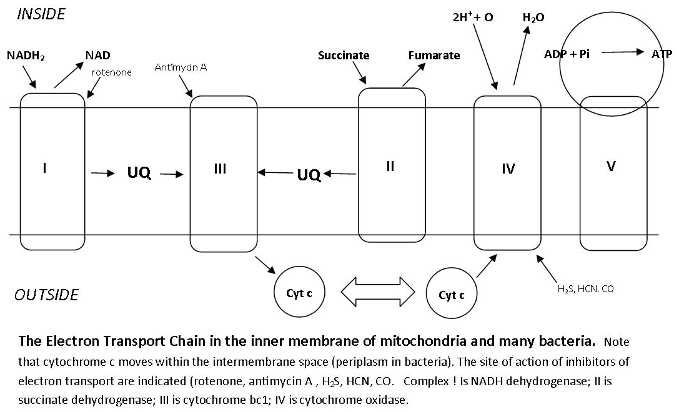

Uncouping agents. For example dinitrophenol, CCCP. These uncouple electron transport from the synthesis of ATP. They do not inhibit any of the ETC components or the ATP synthase. These agents have the same effect as each other but have no chemical similarities. The way they work is only understandable in terms of the chemiosmotic mechanism of ATP synthesis.

How is electron transport (oxidation) coupled to phosphorylation (ATP synthesis)
For many years this was a huge insoluble problem. The Chemical theory said that some (not identified) component of the ETC must become phosphorylated during oxidation of NADH and that the phosphate was then added to ADP to make ATP. PROBLEM: no phosphorylated component could be isolated and there was no way to explain uncoupling agents.
Peter Mitchell, 1961. The Chemiosmotic Hypothesis. Mitchell won the Nobel Prize for this in 1978
Mitchell proposed an indirect interaction between oxidizing and phosphorylating enzymes. The flow of electrons through the enzymes of the respiratory or photosynthetic electron-transfer chains drives positively charged hydrogen ions, or protons, across the membranes of mitochondria, chloroplasts and bacterial cells. As a result, an electrochemical proton gradient is created across the membrane. The gradient consists of two components: a difference in hydrogen ion concentration, or ΔpH, and a difference in electric potential Δψ; the two together form the 'protonmotive force' (pmf). The synthesis of ATP is driven by a reverse flow of protons through the ATP synthase down the electrochemical gradient. [pmf = ΔpH plus Δψ]
A common mistake: Some textbooks forget the contribution of the membrane potential Δψ but this contributes 75% of the pmf in mitochondria and usually 100% in bacteria. In chloroplasts the pmf is 100% ΔpH.
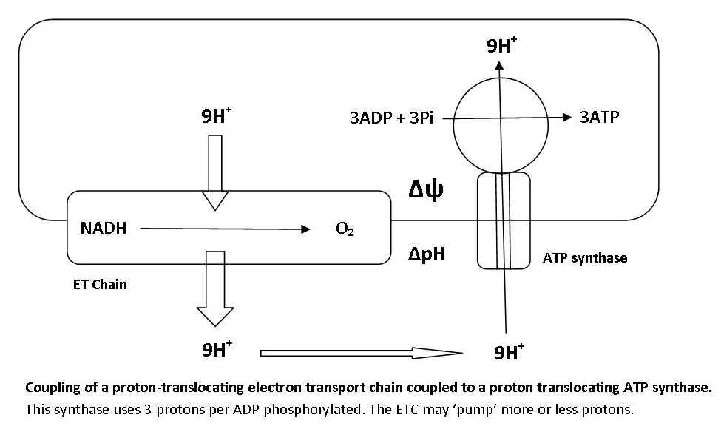

Uncoupling agents. These are weak membrane-soluble acids like dinitrophenol. These can carry protons across the membrane and so cancel out the pmf.
How are protons pumped across the mitochondrial or bacterial membranes?
The process is also called proton translocation. There is more than one type of mechanism for this.
1. Simple mechanism. Some components of the ETC are single electron carriers; others are 2H carriers (2 H⁺ + 2e⁻). The proteins are arranged in the membrane so that protons are taken up on the inside and released on the outside.
Example: Reduction of cytochrome bc1 by NADH dehydrogenase. The Fe/S protein (single e donor) of the dehydrogenase reduces the 2H carrier ubiquinone (UQ) which then reduces the cytochrome b of the cytochrome bc1 complex (single e carrier). Note: the 2e are passed one at a time from the Fe/S to the UQ.
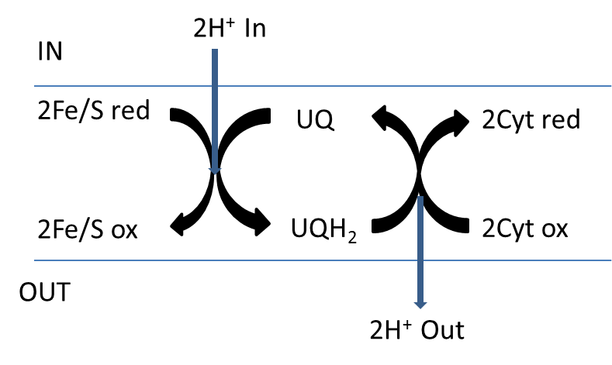
2. The Q-cycle.
3. ‘Extra’ proton pumps. Sometimes more protons are pumped that predicted by unknown mechanism. For example NADH dehydrogenase and cytochrome oxidase.
4. Cytochrome oxidase. This pumps protons by unknown mechanism but also uses protons in its reaction mechanism: 4e (from cytochrome c) + 4H⁺ + O₂ → 2H₂O

Mitchell’s Q-cycle This was proposed by Mitchell (and since established) to account for the stoichiometry of proton translocation during oxidation of ubiquinol byt the cytochrome bc1 complex (more than expected from simple model) as there are no 2H carriers between ubiquinone and cytochrome c. And also to account for the observation that in experiments when a reduced ETC chain is oxidised some cytochrome b becomes more reduced .

The cytochrome bc1 complex contains 2 binding sites for UQ (Qout and Qin); haem bL (lower Eo) and haem bH (higher Eo); Rieske Fe/S protein; and bound cytochrome c1. It catalyses the oxidation of one molecule of ubiquinol (UQH1) by 2 molecules of soluble cytochrome c:
UQH₂ + 2 Cyt c (Ox) + 2H⁺ _{IN} → UQ + 2 Cyt c (Red) + 4H⁺ _{Out}

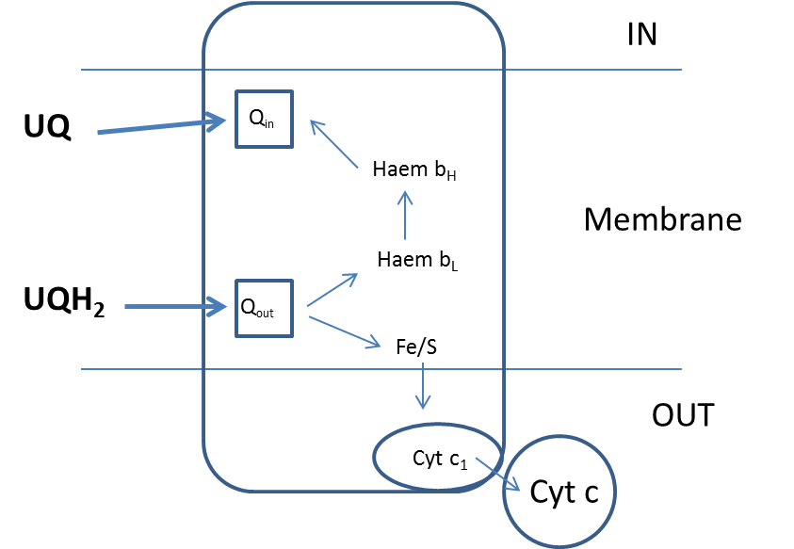
Phase 1: UQ and UQH₂ bind to the 2 sites on the Cytochrome bc1 complex.
UQH₂ at the Q_{out} site donates 1 e to soluble cyt c by way of Fe/S and cyt c₁
And it donates 1 e to UQ by way of the 2 molecules of Haem b
Its 2 protons are released to the outside and the oxidised UQ is released.
At the end of phase 1 one molecule of UQ remains bound to the Q_{in} site as a half-reduced free radical UQ

Phase 2: A second UQH₂ binds to the Q_{out} site.
It donates 1 e to UQIn the Q_{in} site by way of the 2 molecules of Haem b.
This UQ now has 2 electrons; it picks up 2 protons from the inside and is released as UQH₂.
The UQH2 at the Qout site donates 1 e to soluble cyt c by way of Fe/S and cyt c₁
Its 2 protons are released to the outside and the oxidised UQ is released.
Summary
2QH₂ + 2H⁺ in + 2 Cyt c (ox) → Q + UQH₂ + 4H⁺ _{out} + 2 Cyt c (red)
SUM:
QH₂ + 2H⁺ in + 2 Cyt c (ox) → UQ + 4H⁺ _{out} + 2 Cyt c (red)

The total number of protons pumped during respiration in mitochondria is about 9 protons/NADH oxidised and 6 protons / succinate oxidised (because only the Q-cycle and oxidase are involved – not NADH dehydrogenase).
Note There has been much controversy about this because it is difficult to measure. The stoichiometry of 3 protons per ATP is fixed by the mechanism. But there is no need for there to be a fixed stoichiometry for proton pumping during oxidation of NADH etc.
Usually it is assumed that for every NADH oxidised (using a single oxygen atom) 3 ATP can be made (the P/O ratio is said to be 3). During succinate oxidation only 2ATP are made (P/O ratio is 2).

